Project Design Phase-II
Data Flow Diagram & User Stories

Date
Team ID
Project Name
Maximum Marks | 4 Marks

Data Flow Diagrams:
A Data Flow Diagram (DFD) is a traditional visual representation of the information flows within a system. A neat and clear DFD can depict the right amount of the system requirement graphically. It shows how data enters and leaves the system, what changes the information, and where data is stored .
Data Flow Diagram (Level-0) – User Module Data Flow Diagram (Level-0) – Administrator Module
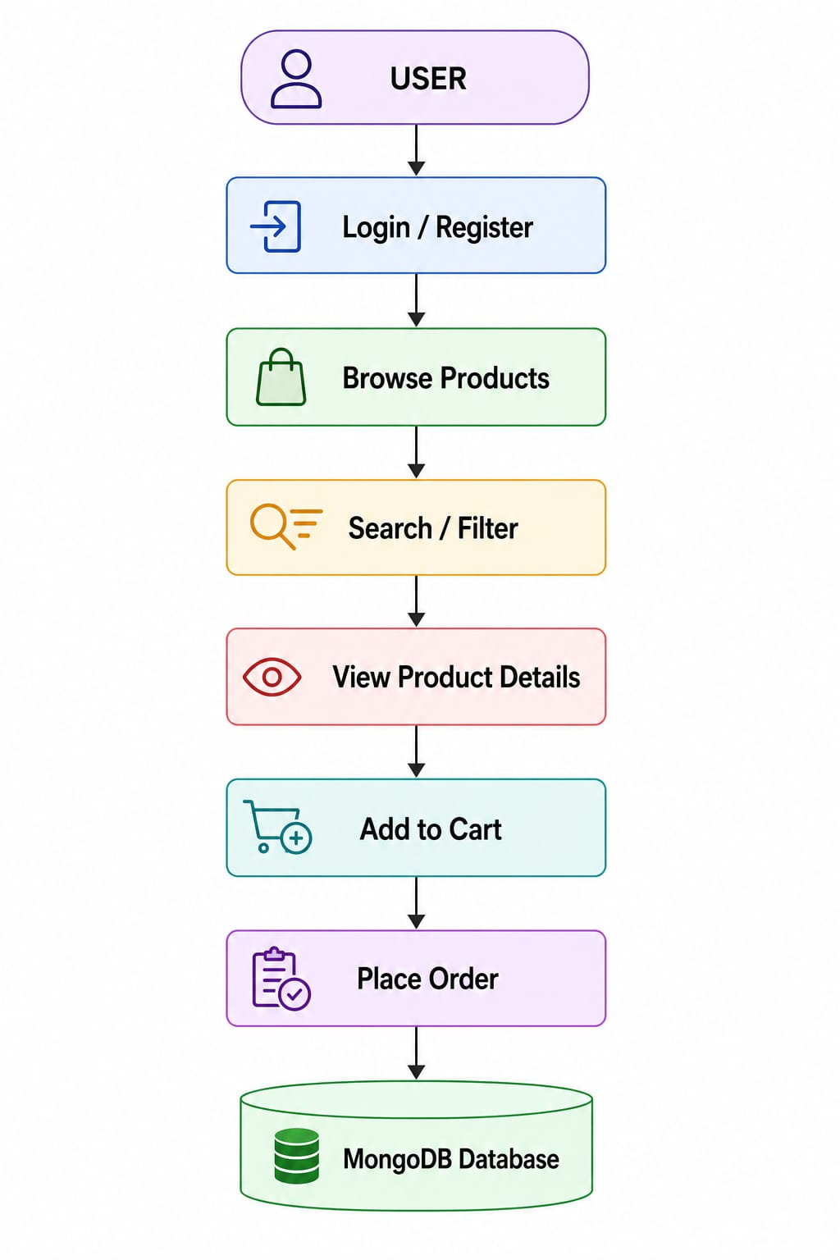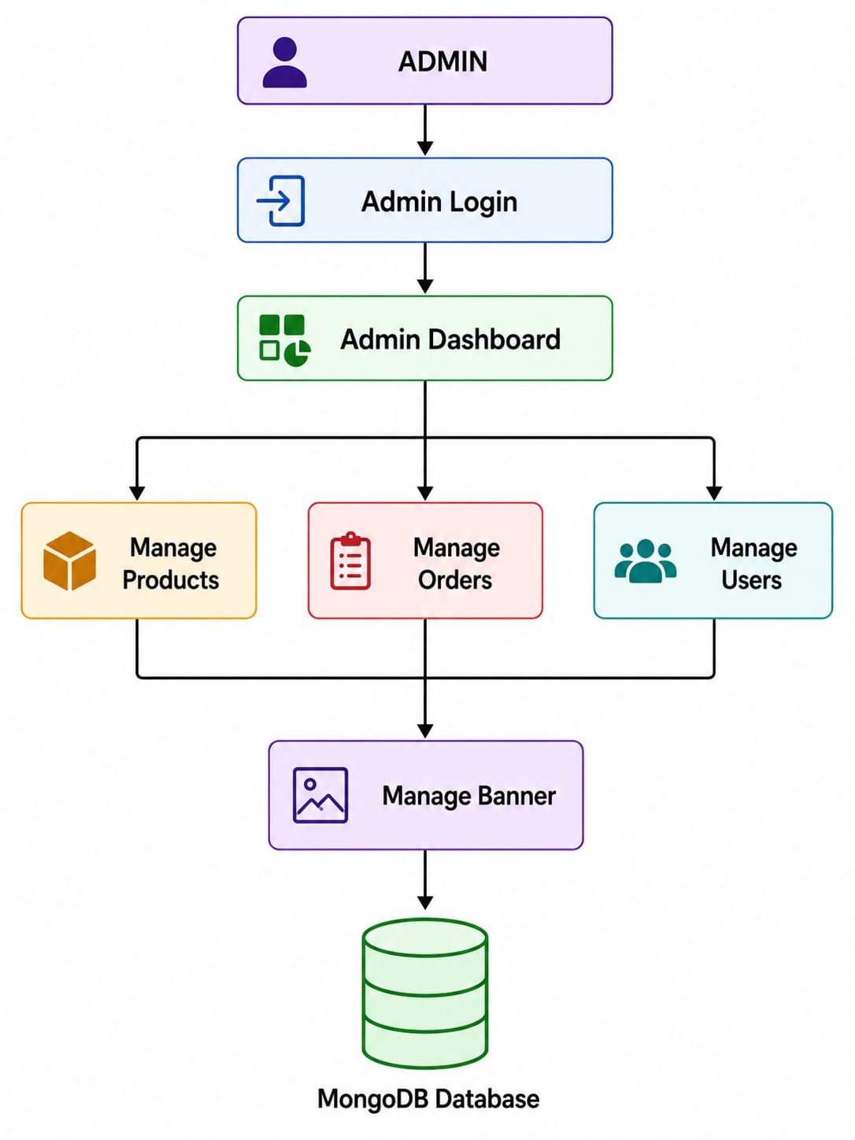
User Stories
Customer (Web User):
Use the below template to list all the user stories for the product.
User Type | Functional Requirement (Epic) | User Story Number | User Story / Task | Acceptance criteria | Priority | Release
Customer  (Web user) | Registration | USN-1 | As a user, I can register using username, email, and password. | User account is created successfully. | High | Sprint-1
Customer  (Web user) | Login | USN-2 | As a user, I can log in using my email and password. | User is redirected to the homepage after successful login. | High | Sprint-1
Customer  (Web user) | Browse Products | USN-3 | As a user, I can browse all available products. | Products are displayed successfully. | High | Sprint-1
Customer  (Web user) | Search Products | USN-4 | As a user, I can search products using the search bar. | Matching products are displayed. | High | Sprint-2
Customer  (Web user) | Filter Products | USN-5 | As a user, I can filter products by sort by,category and gender. | Only selected products are displayed | Medium | Sprint-2
Customer  (Web user) | Product Details | USN-6 | As a user, I can view complete product information. | Product details page opens successfully. | High | Sprint-2
Customer  (Web user) | Shopping Cart | USN-7 | As a user, I can add products to my cart. | Selected product is added to the cart. | High | Sprint-2
Customer  (Web user) | Place Order | USN-8 | As a user, I can place an order from my cart. | Order is stored successfully. | High | Sprint-3
Customer  (Web user) | My Orders | USN-9 | As a user, I can view my previous orders. | Order history is displayed correctly. | Medium | Sprint-3

Administrator :
User Type | Functional Requirement (Epic) | User Story Number | User Story / Task | Acceptance criteria | Priority | Release
Administrator | Login | USN-10 | As an administrator, I can log in securely. | Admin dashboard is displayed. | High | Sprint-1
Administrator | Product Management | USN-11 | As an administrator, I can add new products. | Product is stored in the database. | High | Sprint-2
Administrator | Product Management | USN-12 | As an administrator, I can edit existing products. | Updated product details are saved. | High | Sprint-2
Administrator | Product Management | USN-13 | As an administrator, I can delete products. | Product is removed successfully. | High | Sprint-2
Administrator | Order Management | USN-14 | As an administrator, I can view customer orders. | Orders are displayed correctly. | Medium | Sprint-3
Administrator | User Management | USN-15 | As an administrator, I can view registered users.. | User details are displayed successfully. | Medium | Sprint-3
Administrator | Banner Management | USN-16 | As an administrator, I can update the homepage banner. | New banner is displayed on the homepage. | Low | Sprint-3

